Project Flow: Cube.DocExtract

- Framework: ASP.NET Core Razor Pages (.NET 9)
- Database: SQL Server with Entity Framework Core
- PDF Processing: UglyToad.PdfPig
- OCR: Tesseract (5.2.0)
- Excel: ExcelDataReader
- Frontend: HTML5, Bootstrap, jQuery, AJAX
- Logging: Microsoft.Extensions.Logging

This is a Document Processing & Data Extraction application built with ASP.NET Core Razor Pages (.NET 9) and SQL Server. Here's how it works:
- Architecture Overview

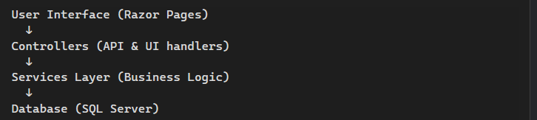

2. Core Components
A. Frontend (UI Layer)
- Views/Home/Index.cshtml - Main dashboard with:
  - Analytics Cards: Display stats (Total Uploaded, Processed Success, In Pipeline, Failed)
  - Upload Section: File upload interface
  - Document List: Table showing all uploaded documents with their status
  - Real-time Status Updates: Via AJAX polling
B. Controllers
HomeController.cs
- Serves the main Index page (dashboard)
- Handles Privacy and Error views
- Basic routing for the UI
DocumentController.cs (API)
- GET /api/document/list - Retrieves all documents with metadata
- GET /api/document/status/{id} - Checks processing status
- POST /api/document/upload - Handles file uploads and triggers processing
- Background Processing - Queues document for extraction after upload
C. Database Layer (Models/)
Entity Models:
- UploadedDocument - Main document record with:
  - File info (name, type, path)
  - Upload date & processing status
  - Raw extracted text
  - Processing time metrics
- DocumentMetadata - Extracted business data (PO numbers, vendor details)
- LineItem - Structured line items from documents (quantities, amounts)
DocumentDbContext.cs - EF Core context managing SQL Server connection
D. Services Layer (Business Logic)
TextExtractionService.cs
- Detects file type (PDF, scanned images, Excel) using magic bytes
- Extracts text from:
  - PDFs → Uses PdfPig library
  - Scanned Images → Routes to OCR service
  - Excel files → Uses ExcelDataReader
OcrService.cs
- Uses Tesseract OCR for image text recognition
- Auto-downloads trained data (eng.traineddata) on first run
- Handles scanned document text extraction
DocumentParserService.cs (Core intelligence - 989 lines)
- Parses raw text using regex patterns to extract:
  - PO numbers
  - Vendor information
  - Line items (products, quantities, prices)
- Parses Excel files directly into structured data
- Uses CultureInfo for number/currency formatting
ExportService.cs
- Exports extracted data in various formats (PDF, Excel, JSON)

